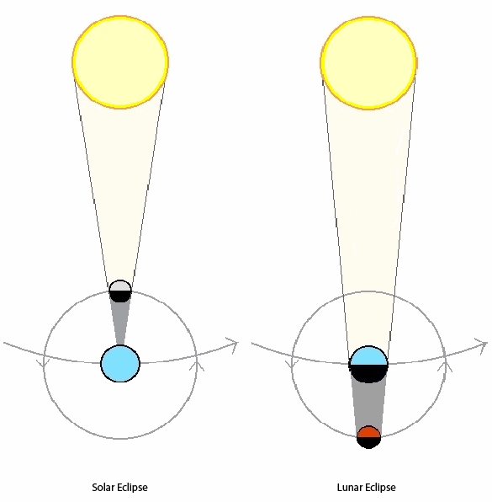
Create an Eclipse Model Manipulative
Name _________________________________ Class ____________________ Date ________
Materials needed: Index cards, Moon, Earth, and Sun circle Templates, coloring utensils, two “arms”, the grading rubric with definitions, 3 brass fasteners and scissors.
Directions: Make a Moon, Earth and Sun model using the circle templates and index cards. Make two “arms” to connect your Moon, Earth & Sun. Write the definitions provided below on the appropriate areas. Be able to verbally describe what happens during a Lunar eclipse and a solar eclipse.
Definitions: DO NOT WRITE THE DEFINITIONS UNTIL YOU HAVE CONNECTED YOUR THREE CIRCLE TEMPLATES IN THIS ORDER: Sun>>>Earth>>>Moon
*Write definitions on one side (color the other side as directed below in the grading rubric.)
Write on the arm connecting the Earth and Moon-It takes the moon 30 days to revolve around the Earth.
Write on the arm connecting the sun and Earth- The Earth takes 365 days to revolve around the Sun.
Write on the back of the Sun Circle- A solar eclipse is when the light of the Sun is blocked by the moon and cannot be seen by Earth. The moon is positioned between the Earth and the sun. The phase of the moon is NEW.
Write on the back of the Earth Circle- It takes the Earth 24 hours to rotate on its axis.
A Lunar Eclipse is when the moon cannot be seen from the Earth. The earth is positioned between the sun and moon. The phase of the moon is FULL.
GRADING RUBRIC:
The size of your circles represent the Sun, Earth & Moon correctly ___5
You included the definitions on your celestial bodies correctly ___50
You colored each of your circles (moon-gray), Earth (green & blue), Sun (yellow) ____15
You were able to describe the solar and lunar eclipse correctly ____25
You included your name and class color below ____5
Total points _____ 100 Grade earned ______

